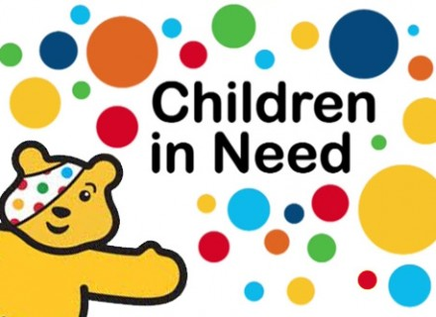
Tuesday 7 November 2017

Re: Children in Need Day

Dear Parent or Carer
Friday 17 November is Children in Need Day and this year’s theme is “Spotacular”!

Please help to support the charity and help raise money for disadvantaged children by sending your child to school on Friday 17 November in a spotty item of clothing, along with a charitable donation of £1. All donations we receive will be given to Children in Need.
Along with this letter, we are also sending out a document with some ideas for spotty clothes. Please have a look through, but feel free to come up with your own. It would be great to see every single child at Concordia taking part in this important national event.
On the day, a member of staff will be collecting additional donations outside the school bus, anything you give will be donated to Children in Need.
Do let me know if you have any questions.
Yours sincerely

Raheel Akhtar
Headteacher

School contact number: 01708 932 710
School email: info@concordiaacademy.co.uk

