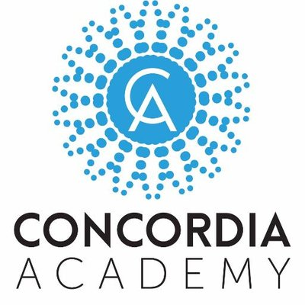
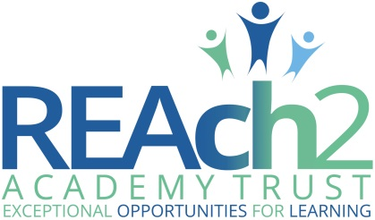

21st September 2017

Dear Parent/Carer

Please see attached the current collection information we have for your child. This should show only the names of people who are authorised to collect your child from school, or the bus stop at the end of the day.

If these details have changed or are incorrect then please update the sheet in the empty boxes to show the correct authorised names. If the information we hold is correct you do not need to respond to this letter.

If you have any additional information regarding the collection of your child, please include this under the ‘Additional Comments’ section.

The children’s safety is a key priority and therefore it is extremely important that we have the correct information on record. If someone was to arrive to collect your child and we did not have their information on file, we would not be able to allow them to do so.

If this information or any of the information we have for you were to change in the future, you must notify the office in writing immediately. In the next few weeks we will be collecting other essential information and we would appreciate your co-operation in returning these forms to us complete, and as quickly as possible.

Enjoy the weekend and we will see you Monday.

Yours sincerely,

Raheel Akhtar
Headteacher

School contact number: 01708 932 710
School email: info@concordiaacademy.co.uk

